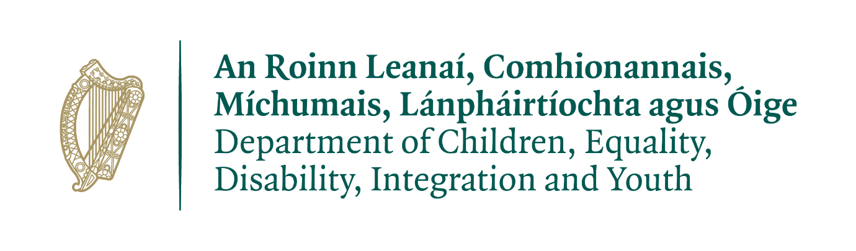

Opportunities for Youth: An Action Plan for Youth Services

Submission Template

|  |
| --- |
| **Respondent Profile** |

|  |  |
| --- | --- |
| **Name** |  |
| **Email Address** |  |
| **Organisation/Body**  **(if applicable)** |  |
| **Role (if applicable)** |  |

|  |  |
| --- | --- |
| **Are you making this submission on behalf of the organisation or body named above or as an individual?** | |
| **Organisation/Body** | **Individual** |

|  |
| --- |
| **What is your experience of youth services, if any? (200 words max - bullet points can be used if preferable)**  *In your answer, you may wish to include:*   * *which type of service you are familiar with* * *if you are a past or current participant, a parent, a youth worker or volunteer, someone working in a different sector etc.* |
|  |

|  |
| --- |
| **Consultation Questions** |

|  |
| --- |
| 1. **What are your views on access to youth services? (600 words max – bullet points can be used if preferable)**   *In your response, you may wish to consider:*   * *any barriers that exist to equality of access either for all young people or for particular cohorts of young people*, *including geographical* *barriers* * *any measures you propose to enhance access and the inclusion of all young people* |
|  |

|  |
| --- |
| 1. **What are your views on quality in youth services? (600 words max – bullet points can be used if preferable)**   *In your response, you may wish to include:*   * *what you consider to be the indicators of high quality services* * *what are the factors that support high quality services* * *any proposed measures to enhance quality in youth services* |
|  |

|  |
| --- |
| 1. **What are your views on collaboration and co-operation within the youth sector and between the youth sector and other sectors?** (**600 words max – bullet points can be used if preferable)**     *In your response, you may wish to consider:*   * *any benefits you see for young people from collaboration* * *any good practice examples* * *any barriers that exist* * *relationships with and between different funding bodies* * *any proposed measures to enhance collaboration and co-operation.* |
|  |

|  |
| --- |
| 1. **How can we strengthen the role of youth services in supporting young people’s rights? (600 words max – bullet points can be used if preferable)**   *In your response, you may wish to consider among other things:*   * *young people’s rights to safety and development, to be heard, to be treated without discrimination, to have equal access to services and to leisure, play and recreation* * *the youth sector’s role in promoting human rights and equality* |
|  |

|  |
| --- |
| 1. **What measures are needed to ensure that we have sustainable and effective youth services into the future?** **(600 words max – bullet points can be used if preferable)**   *In your response, you may wish to consider the broader structures that support youth service delivery including issues of funding, recruitment and training, access to premises, availability of data and research, and innovation and responses to emerging issues.* |
|  |

|  |
| --- |
| 1. **Please share below 1) any other proposed measures that you think should be included in the Action Plan for Youth Services and 2) any other comments or information that the Department should take into account while developing the Action Plan. (600 words max – bullet points can be used if preferable)** |
|  |